The Bonkulator

User Manual

Greenface Labs -- 2022

Table of Contents

Description 3

Quick Start 3

Overview 5

Signals 5

Functions 5

Controls 5

Features 6

Front Panel 7

Open-Source Project 8

Operation 9

General Operation 9

Output Signals 10

CV Inputs 10

Screen Saver 10

Output Details 11

Settings Details 11

WiFi 12

Terminal Mode 14

Settings 18

Software Update 18

Crash Recovery 19

# Description

The Bonkulator is a 14HP Eurorack module that generates signals that can be used to modulate voltage-controlled functions such as VCO, VCF, VCA, etc... Eight independent outputs can be triggered by any of four trigger inputs and can also be modulated by the two input signals. Eight coordinated outputs in one module means that the Bonkulator is a very powerful addition to anyone’s rack! In addition to the front panel controls, the Bonkulator provides a Web interface via WiFi and a Terminal interface via USB. These additional interfaces enhance the user experience and bring a greater level of controllability to the module.

# Quick Start

The Bonkulator can be used in an endless variety of ways, but here is a great way to start exploring. These instructions are for use with a Moog Mother-32 but can be easily adapted to most modular synthesizers. Addition of an Echo module is highly recommended.

#### Mother-32 Set-up

* VCA Mode – ON (do not use the envelope generator)
* VCO Mod Amount – 50%
* VCO Mod Dest - Frequency
* VCF Mode – Low Pass
* VCF Mod Polarity – +
* LFO Wave – triangle
* LFO Rate – 30%
* Cutoff – 50%
* Resonance – 20%
* Sustain – Off
* Frequency – 50%
* Pulse Width – 50%
* VCO Wave - Pulse
* Octave – 4
* Note – 8

#### Bonkulator Set-Up

* Output 0 (use default parameters as shown in images below)
  + Waveform: Ramp Up
  + Period: 03010
  + Delay: 00000
  + Repeat: 30000
  + T0: Enabled
  + T1: Disabled
  + T2: Disabled
  + T3: Disabled
  + CV0: Off
  + CV1: Off
  + Scale: 100
  + Offset: 000
  + Randomness: 00
  + Quantize: No
  + Idle Value: 0512
* Output 1
  + Waveform: Ramp Down
  + Period: 03010
  + Delay: 00000
  + Repeat: 30000
  + T0: Enabled
  + T1: Disabled
  + T2: Disabled
  + T3: Disabled
  + CV0: Off
  + CV1: Off
  + Scale: 100
  + Offset: 000
  + Randomness: 00
  + Quantize: No
  + Idle Value: 0512

Connect the Bonkulator Output 0 to the M-32 VCO 1V/Oct input and the VCF Cutoff input. Connect Output 1 to the M-32 LFO Rate input. Press Trigger 0 on the Bonkulator and you should hear a sound much like that found [here](https://www.greenfacelabs.com/wp-content/uploads/2022/07/bonkulator_quick_start.mp3). Try increasing the Randomness on Output 0 to 20.

# Overview

The Bonkulator is a Eurorack module that fits into a 3U x 14HP slot. It features 8 programmable outputs and 6 programmable inputs. The front-panel user controls consist of a 128×64 pixel 2-color OLED display, a rotary encoder for adjusting parameters and a button for each trigger and output.

Pressing and holding the trigger buttons toggle the trigger enable/disable. Pressing the output buttons brings up the configuration menu for each output.

Pressing the Adjust Knob activates various functions of the Bonkulator. The use of this button is context-sensitive and is only active within the Settings function. Pressing and holding this knob for longer than 2 seconds brings up the Settings function.

In addition to the front panel controls, the Bonkulator provides WiFi and Terminal interfaces. The WiFi interface is a REST API and the Terminal interface is ANSI X3.64 via the Arduino micro-USB connector. These interfaces greatly extend the usefulness and capabilities of the Bonkulator. Scripting, patch management, dedicated GUIs and even Internet-connected IoT apps are now possible. And using a remote interface means that you no longer have to adjust tiny dials amid a forest of patch cords. This benefit cannot be fully appreciated until it is experienced directly.

## Signals

* Outputs (8) – Analog signal (+/- 5 volt). Built-in and programmable waveforms.
* Triggers (4) – Digital signal that is activated by a 0 to +5V transition.
* CV (2) – Analog signal input. Range: +/- 5 volt

## Functions

* Output (0-7) – For configuring the 8 outputs
* Settings – For module configuration, WiFi , factory reset, etc.

## Controls

* Output Buttons (0-7) – For selecting from the 8 outputs
* Trigger Buttons (0-3) – For manual triggering
* Move Buttons (^v<>) – For navigating the display.
* Adjust Rotary Encoder – For adjusting selected parameter
* Activate Push Button – Push the Adjust knob to activate functions
* More controls are available via Web and Terminal interfaces

## Features

* A 128x64 two-color OLED graphic display enhances usability
* Web and Terminal interfaces provide rich user experiences with the addition of computer resources like a keyboard, mouse, display and scripting.
* All settings are stored in Flash memory so that they are retained when power is off
* Inputs and Outputs are protected against damage during typical use
* Output and Input LED indicators show voltage levels present at the jacks
* Trigger Indicator LEDs show if any Outputs have been activated by that trigger
* A 1U expansion module is available that provides an external USB interface with some interesting extra features. See “The BonkDaddy”.

## Front Panel

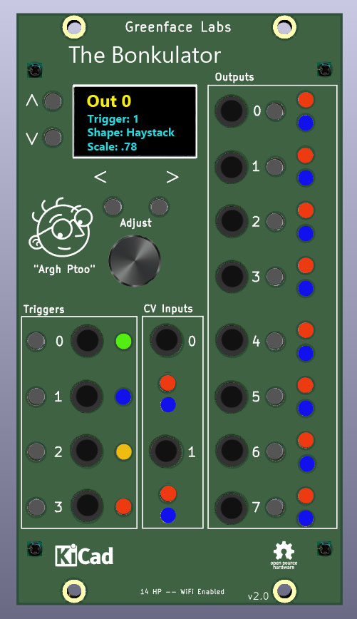

Figure 1 - Front Panel

## Open-Source Project

The Bonkulator is an Open-Source project that has an Arduino 33 IoT at its core. The code is written in C++ and makes use of several public domain code libraries for managing the various purchased hardware components such as the display and the FRAM non-volatile memory.

Because it is Open Source, in addition to being used by musicians and sound designers to create new and amazing sounds, the Bonkulator can be used by students and entrepreneurs to create new, amazing modules. And, of course, the open-source community will generally improve the product as times goes along. Links to the design repositories can be found on the Bonkulator web page.

# Operation

## General Operation

The typical procedure for using the Bonkulator involves choosing a set of waveforms that are needed for a particular application. Then a set of triggers are defined and the various parameters for each waveform are entered. Once configured, the Bonkulator reacts to trigger signals, sending the waveform for each Output that was triggered.

* The Output is selected using the Output buttons.
  + Terminal uses the **‘f’** command.
  + Web Interface has dedicated Function buttons.
  + Each Output has several parameters.
  + Waveforms are selected as one of the parameters
  + Choose from 6 pre-installed waveforms and 8 user-entered waveforms.
* Parameters are adjusted using the arrow keys and the Adjust knob.
  + Parameters are selected using the **up** and **down** arrows.
  + Digit to be adjusted is selected by using the **right** and **left** arrows.
  + Use the Adjust knob to increment and decrement the selected digit.
  + Parameter values may be directly entered using the Terminal or Web Interface.
* Enable Triggers for each Output that is to be used
  + Outputs can be triggered by any or all of the four triggers.
  + Triggers T0 – T3 can be either ENABLED or DISABLED. They are set as above.
* Operation of each Output is triggered by a variety of methods.
  + Pressing the selected trigger button. (Manual trigger)
  + Receiving a low to high transition on the selected Trigger jack.
  + Terminal uses the ‘**!**’ key to trigger the selected trigger.
  + Web Interface has a dedicated Trigger button for each trigger.
* If an Output is already triggered, receiving a trigger command will stop the output.
  + Trigger signals effectively toggle the Output state. (Triggered or Idle)
* Output amplitude, offset and period can be modulated by the two input signals.
  + Set CV0 and CV1 to select the modulation target (scale, offset, period, or off).
  + If both CVs are specified, the effect is to cascade CV1 after CV0

## Output Signals

The Output signal ranges from -5.33V to +5.33V.

When the Trigger isn’t active, the **Idle Value** is sent. Use Output parameters to select the Idle Value.

Web mode has a dedicated slider control for each CV parameter, and Terminal mode uses the S, O and c keys followed by a number. See the table of remote commands for more details.

## CV Inputs

The two CV In jacks have a range of -5V to +5V. They are used to modulate the Outputs. Configure the Outputs to target the scale, offset or period for each CV input. If both CV Inputs are specified the effect will be cascaded with CV0 being applied first.

## Screen Saver

In order to maximize display life, the display will turn off after a set time. The default time is 15 minutes. The time can be set in the Settings function with a range of 1 to 9999 minutes.

Press any button or send the ‘z’ command to bring the display back.

# Output Details

The Bonkulator Outputs have several parameters. Details for each parameter follow.

1. Waveform
   1. There are 14 waveforms available, six are factory-installed and eight are user-defined. See Settings->User Waveforms for more details. The factory waveforms are as follows:
   2. Sine,Inv Sine,Ramp Up,Ramp Down,Pulse,Inv Pulse
2. Period
3. Delay
4. Repeat
5. Trigger 0
6. Trigger 1
7. Trigger 2
8. Trigger 3
9. CV 0
10. CV 1
11. Scale
12. Offset
13. Randomness
14. Quantize
15. Idle Value

# Settings Details

The Bonkulator has several settings that affect the overall operation. Details for each setting follow.

1. Software version (read-only)
2. Name
3. Encode Type
4. WiFi Enable
5. Screen Saver Timeout
6. User Waveforms Editor
7. Factory Reset
8. Calibrate Inputs/Outputs

## WiFi

The Bonkulator is equipped with a 2.4GHz WiFi interface. When connected to your network, you can control the Bonkulator using the [Web Interface](https://www.greenfacelabs.com/bonkulator-control/) (see example screen below).

WiFi can be disabled in the Settings function. Make sure it is enabled before proceeding in the connection process.

#### Connecting to WiFi

1. Enter WiFi function and press Trigger to scan for networks.
2. Use the up and down arrow keys to select your network. Press Trigger.
3. Use the right and left arrow keys with the Adjust control to select each character of your password. Press Trigger when your password is entered. Note: It is much easier in Terminal mode. Type your password preceded by $, then press Enter.

The Bonkulator will try to connect using the password that you entered. If successful, the screen will display the connection data. This includes the connection status, the IP it can be found at and the signal strength. The signal strength will also be displayed in the upper right corner of the display as 1-4 bars. The signal strength display is shown in most functions.

If the connection fails, the Bonkulator will give its best explanation of why it failed.

The Bonkulator remembers its connection and will reestablish it if the power is recycled.

Visiting the WiFi function again while connected will display the connection data. Press Trigger to re-enter the scan for networks screen.

Re-scanning networks will reset the password, so it must be entered again to connect.

#### Using WiFi

The Bonkulator’s Web Interface was designed to resemble the physical front panel. However, because the Web Interface enjoys the added functionality a computer brings, it has significant differences. Please refer to the following image.

While you can still adjust parameters a digit at a time, you can now enter parameters from the keyboard by first clicking on the parameter then using the dedicated entry field.

Adjusting parameters digit by digit is possible by using the right and left arrows to select the digit and using the Inc and Dec buttons to increment and decrement the digit.

Figure 10 - Web Interface ExampleGraphical user interface

Description automatically generated

## Terminal Mode

Terminal mode is accessed via the MicroUSB connector on the Arduino that is on the bottom of the Bonkulator. It is always available and cannot be turned on or off.

Use a terminal emulation program like PuTTY that has VT-100 mode. The Bonkulator is set to run at 115200 baud but will adapt to the PuTTY settings.

Please refer to the table of commands that follows this section.

#### Terminal Example Screen

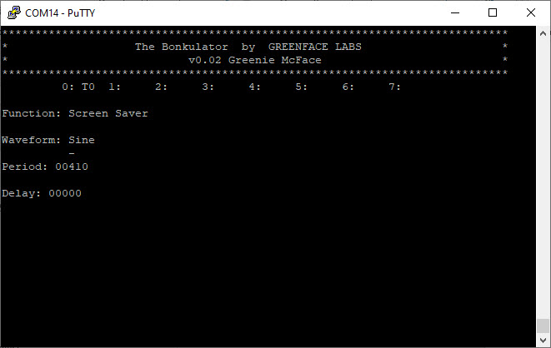

Figure 11 - Terminal Interface Screen

Important! Only connect USB to a powered-up system. Otherwise, the 5V power from the USB will try to power the entire rack. And that’s not really good. So, please disconnect the USB cable before you turn off the power.

You can get around this by using the BonkDaddy which disconnects the USB power when the Bonkulator is turned off.

#### Commands

|  |  |  |  |
| --- | --- | --- | --- |
| **Command** | **Front Panel** | **Terminal** | **Web** |
| Previous Parameter | ^ | [A | ^ |
| Next Parameter | v | [B | v |
| Next Digit | > | [C | > |
| Previous Digit | < | [D | < |
| Increment Digit | Adjust clockwise | u | Inc |
| Decrement Digit | Counter-clockwise | d | Dec |
| Settings Function | Press & Hold ADJ | * | Settings |
| Disable Displays |  | Z |  |
| Restore Displays |  | z | Refresh Browser |
| Trigger Selected |  | ! | Use T0-T3 |
| Go To Function | Press Output | fx | Click Fxn Name |
| Select Parameter |  | px | Click on Param |
| Select Digit# |  | :xx |  |
| Enter Number |  | xxx… | Use Param Input |
| Enter Number (alt) |  | #xxx… | Use Param Input |
| Enter String |  | $xx… | Use Param Input |
| Offset | Use Adj | Oxxxx | Use Offset slider |
| Scale | Use Adj | Sxxx | Use Scale slider |
| Randomness | Use Adj | Rxxx | Use Random slider |
| Quantization Off |  | Q0 |  |
| Quantization On |  | Q1 |  |
| Idle Value |  | Vxxxx |  |
| Display Off |  | J0 |  |
| Display On |  | J1 |  |
| Select Trigger |  | tx |  |
| Clear Trigger |  | rx |  |
| Disable Selected Trig |  | T0 |  |
| Enable Selected Trig |  | T1 |  |
| Toggle Selected Trig |  | T2 |  |
| Disable All Triggers |  | D0 |  |
| Trigger All Triggers |  | D1 |  |
| Clear All Triggers |  | D2 |  |

Notes:

* Commands with yellow background require the user to press Enter when using a terminal. **Not** **Required** when sending via Web (REST interface).
* Go To Function – x means to enter a single digit in the range of 0-8
* Select Parameter – x means a single digit in the range of 0-n, where n = the number of parameters for a chosen function minus 1.
* Enter Parameter – xxxx means up to 4 digits depending on the parameter. The range also depends on the parameter.
* Under the hood, the Web interface uses the same command characters as the Terminal
* Disable Displays (Z) is used to speed up remote scripting. Restore Displays by using the command ‘z’. These commands affect both the OLED display and the remote terminal.
* Display On (J1) and Display Off (J0) just affect the OLED display. Turning off the OLED display noticeably speeds up response when using the terminal interface.

## Settings

The Settings function displays information about the Bonkulator as well as allowing some adjustments to various system parameters. Refer to the table below.

|  |  |  |  |
| --- | --- | --- | --- |
| **Parameter** | **Min** | **Max** | **Default** |
| Version | -- | -- | Displays version# |
| Clock | Internal | External | Internal |
| Encoder Type | Normal | Reverse | Normal |
| WiFi | Enabled | Disabled | Enabled |
| Screen Saver | 1 | 9999 | 15 |
| Reset | -- | -- | Push Trigger |
| Calibrate | -- | -- | Push Trigger |

Notes:

1. **Version** shows the software version number. This is useful when communicating about bugs and questions.
2. **Clock** can be set to External. In this case pulse lengths are irrelevant, but the levels at CV Out will be the same as they would in Internal mode. Feed the External Clock signal into Trig In.
3. **Encoder Type** takes the two types of rotary encoder into account. This makes them easier to purchase if one type is unavailable. If your Adjust knob is working opposite as it should, this is the setting that corrects it.
4. **WiFi** can be disabled here if you want to turn it off but retain your password.
5. **Screen Saver** prolongs the life of the OLED display. The screen will blank after the set number of minutes. Press any button to bring the display back.
6. **Reset** brings the Bonkulator’s parameters back to their factory defaults. Note that WiFi parameters are unaffected.
7. **Calibrate** is a factory-only setting. Do not use.

## Software Update

When a software update becomes available, it will be posted on the website as a zipped package. The package contains 3 files. Unzip these into an empty folder on your machine.

1. Bossac.exe
2. Bonkulator.ino.bin
3. Update.bat

These files work for the Windows OS. Mac and Linux users must install the GUI version of bossac and use that instead. Bossa can be found at: <https://www.shumatech.com/web/products/bossa>

Follow these steps to update the code. This procedure ensures that your rack won’t be inadvertently powered by the USB +5 volt supply.

1. Note: If the update changes the EEPROM storage mapping, the unit will automatically initiate a Software Reset. Any stored settings will be lost, so make sure to save these settings before updating if they are important.
2. Turn off power to the rack and remove the Bonkulator.
3. Leaving the power cable connected, place the Bonkulator on a non-conductive surface. Make sure nothing touches the Bonkulator that might cause a short.
4. Re-power the rack and plug micro-USB cable into the Bonkulator.
5. Run update.bat. It will show available COM ports. Choose by entering the number of the port.
6. If it connects properly, you will see a bunch of text being printed to the screen. This can generally be ignored. If the update succeeds, the Bonkulator will reboot as normal with the new software installed. You should see the new version number in the greet screen.

## Crash Recovery

When things go wrong, as they sometimes do, the Bonkulator might become unresponsive. When this happens, the program must be reset. Usually recycling the power* will fix the problem, but occasionally things have gone so bad that the code must be reloaded.

Usually, following the above update process will work. But occasionally things might have gone so bad that a hardware reset must be performed. There is a reset button on the Arduino 33 IoT. Pressing this twice quickly will force the Arduino into bootloader mode. You will see the yellow LED pulsate to indicate when the Arduino is in bootloader mode. The update process should work at this time. Please contact Greenface Labs directly if this doesn’t work.

*Make sure to unplug the USB cable before removing power.